JOB DESCRIPTION

JOB DETAILS

Job Title: Service Desk Manager

Hours: 37.5 hours per week

Unit/Department: Information Services (IS)

Reports to: Group - Head of IT

Tenure: Permanent

JOB PURPOSE

We have an exciting opportunity for a technical Service Desk Manager to join our small but effective IT Team delivering all IT services across Rowcroft Hospice and St Luke’s Hospice in collaboration with the wider healthcare partnership, in Devon. You will lead on IT service quality, and drive incident response and resolution against agreed service levels.

You will manage and develop the provision of a customer centric IT Service Desk to support clinical and business services, driving a culture of service excellence.
You will engage and motivate the Service Desk team, promoting a best practice environment by growing the knowledge base of the team and closely monitoring performance and personal development. You will own, manage, develop and continually improve key Service Desk processes and controls. Key to this role will be developing KPIs and metrics to measure and drive service performance with regular reporting into the senior management team.

A commitment to quality of service, excellence in healthcare and the development of IT capabilities and services is integral to this role. We are looking for someone who can work effectively in a team but has the energy and determination to take responsibility and drive improvements. You will be someone who cares about customer satisfaction, with excellent communication skills and a drive to keep all stakeholders informed of progress.

You will be a technical expert with strong experience in investigating, diagnosing and resolving desktop, network, data and other support issues.

DIMENSIONS

Rowcroft Hospice, Torquay and St Luke’s Hospice, Plymouth work in close collaboration with each hospice delivering IT services through their own IT Teams but the teams are currently undergoing significant transformation; this is an exciting opportunity to shape the future of IT operations across both Rowcroft Hospice and St Luke’s Hospice.

The post holder will be based at Rowcroft Hospice, in Torquay, but will be required to travel to St Luke’s Hospice in Plymouth, community sites and other hospices where required.
A flexible work approach which requires both scheduled on-call and out of hours work as well as unscheduled out of hours work will be essential.
You will line manage a small incident support team and will be responsible for the prioritising of support tickets and working with the team to allocate and resolve these within service levels. This role will work closely with users, management, the internal hospice IT Teams, support teams from other hospices, partners, and suppliers.

ORGANISATION CHART
The following organisational model will be developed over the coming months, but shows the Service Desk Manager vacancy:

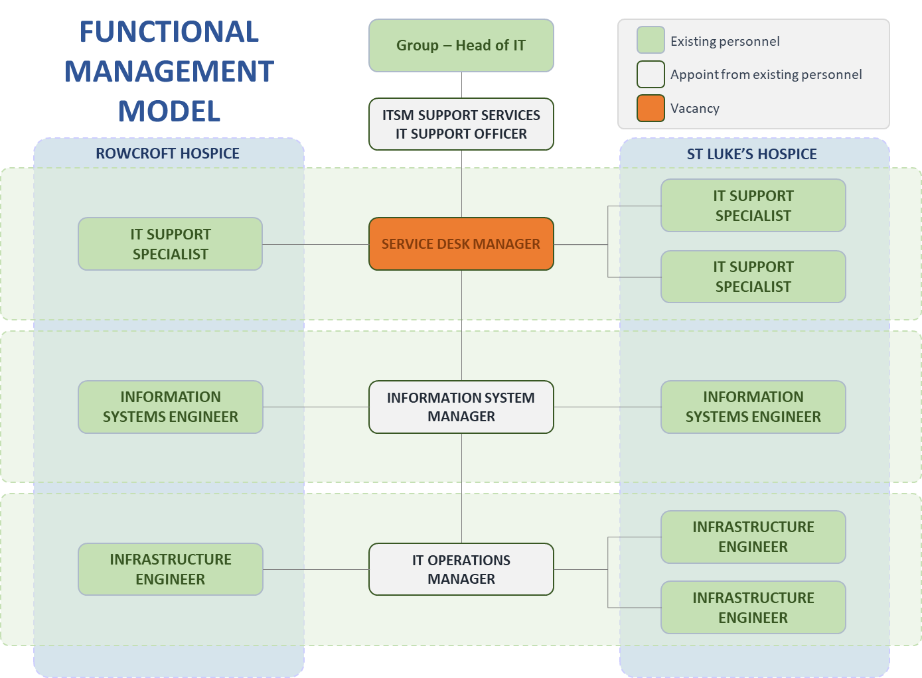

PRIMARY DUTIES AND RESPONSIBILITIES
We have a clear business and IT strategy which defines thinking and shapes our programme of change for the future and the culture to optimise the use of IT for maximum benefit to the hospice, our patients, family, friends, supporters, staff and other valued stakeholders.

Delivering a best in class customer experience for everyone
- Manage demands across all teams for support related activities and provide 1st and 2nd line technical support
- Ensure that IT incidents are promptly actioned and resolved against agreed service levels
- Maintain clear and transparent communications with users and other stakeholders, including comprehensive recording of findings, actions and outcomes
- Manage front line support staff, ensuring they are skilled to deliver outstanding customer support through excellent communications with empathy and underpinned with the technical skills to resolve first call fixes, wherever practical
- Deliver innovative and cost-effective solutions to drive improvements and develop services to new heights
- Act with sensitivity and confidentiality, when dealing with information and any person involved in that confidential information
- Work within the regulatory requirements, codes and guidance relating to both IT and all other aspects of work for the hospices

Supporting resilient services
- Apply technical skills to resolve 1st and 2nd line technical issues, including:
- Microsoft Windows Server, Linux and VMWare support
- Administration of Active Directory, group policy management, DHCP, DNS
- Office 365 administration, file and directory permissions, user support queries and request fulfilment
- Application account management, access rights control, groups configuration and licence allocation
- Network support, including server, router, switches, firewalls, SANs and NAS
- Connectivity support, including telephony, cabling, port configuration and resolving other common comms related support issues
- Hardware break/fix, configuration and optimisation
- Providing advice, guidance and training to optimise the IT user experience and develop confidence in using IT
- Service Desk and incident management activities to support IT users and ensure normal service operation is effective and available
- Software licencing, certification and domain management
- Access management and information security
- Monitoring and responding to system alerts and threshold breaches
- Escalating to 3rd line support, subject experts and/or suppliers
- Maintaining communications with teams and management when escalation of issues is required
- Conducting incident reviews and producing major incident reports
- Form part of the IT on-call rota, providing out of hours support as a part of a rolling-rota with others
- Adhere to change management best practice including receipt, recording, prioritisation categorisation and fulfilment of changes against a defined change management process

Building ‘One Team’
- Working across hospice teams in a seamless and integrated way, leveraging technology to maintain clear working priorities and attending on site, where required
- Work closely and collaboratively across all IT Team members to understand non-support demands and prioritise support issues to meet SLAs and agreed commitments
- Doing the right thing by driving a culture of high-quality customer service by managing and exceeding expectations and through regular updates to users regarding progress on incidents and other activities
- Work collaboratively with other organisations to learn, adopt, comply and improve service delivery to bring efficiencies to end of life care services within the hospices and partnering organisations
- Facilitate third party management, liaising with vendors and facilitating technical support; supplier management ensuring value for money services and appropriate contractual and service level compliance
- Represent IT on various committees and meetings, which could include representatives from other disciplines and organisations
- Being a management escalation point for the on-site team, even when there is no direct line management responsibility; leading by example and supporting a culture of professionalism and productivity

Developing ‘One System’
- Working towards our strategic goals to identify opportunities to improve and simplify IT use to bring operational efficiencies to all hospice IT users
- Providing project management or project support in the development of new IT solutions and innovations
- Relate current and emerging technologies to clinical and business activities for the hospice, identifying new and innovative ways of developing services
- Supporting IT change to develop a single system which improves access to IT services and streamlines access management

Empowering Users
- Define, document, train and communicate best practice policies and processes across the IT Teams, users and other relevant parties
- Implement innovative self-service solutions which work for staff and improve their confidence and efficient use of IT services
- Deliver support, guidance, advice and training to improve individual and organisational skills and capabilities which will improve the use of IT to realise efficiencies and endorse a culture of IT confidence
- Innovate ideas and practices which will embed IT use and a culture of IT confidence into all technology users

PLANNING AND ORGANISATION
- Plan and organise own time
- Facilitate effective planning and prioritisation of activities line reports and other IT support staff
- Work closely with senior managers to understand changing business prioritise, required IT service levels and emerging technology needs

PHYSICAL SKILLS
- Long periods of time using keyboard and Visual Display Unit
- Carrying and installing some IT equipment
- Ability to drive with a clean driving licence, to travel between hospice sites and other partner locations

POLICY AND SERVICE DEVELOPMENT
- Be responsible for developing and maintaining standard operating procedures covering all IT Service Support disciplines and others are required

INFORMATION RESOURCES
- Always maintain confidentiality and the integrity of data
- Leading and supporting on the investigation of information security and data relate incidents
- Responsible for ensuring the confidential maintenance of any information being stored both computerised and paper based for patients, carers and staff
- Provide statistical information, reporting and dashboard insights as required

RESEARCH AND DEVELOPMENT
- Contribute towards the ongoing development of Rowcroft Services
- Undertake surveys or audits

FREEDOM TO ACT
- Ability to prioritise own workload on a daily basis
- Will support, mentor and nurture staff to improve their skills and behaviour

COMMUNICATIONS AND WORKING RELATIONSHIPS
- Be the voice of IT customer excellence for the hospices
- Facilitate internal and external steering group meetings in collaboration with line managers, relating to connectivity needs and other network related services
- Liaise with administrative colleagues in ensuring effective operational management of IT services within agreed SLAs
- Timely communications through multiple channels with users, patients, family, friends, suppliers and partners on the progress and actions taken and planned to resolve any support related activities

MOST CHALLENGING PART OF THE JOB
Working across hospice sites and working to standardise operational practice and technology implementation to realise both financial savings and support efficiencies.

AUDIT CLAUSE
All members of staff are expected to participate in audit assessments as appropriate.

INFECTION CONTROL CLAUSE
Infection control is everyone's responsibility. All staff, both clinical and non-clinical, are required to adhere to the organisation's Infection Prevention and Control Policies and make every effort to maintain high standards of infection control at all times, thereby reducing the burden of Healthcare Associated Infections including MRSA.
All staff employed by Rowcroft Hospice have the following key responsibilities:
- Staff must decontaminate their hands prior to and after direct patient care or contact with the patient's surroundings;
- Staff members have a duty to attend mandatory infection control training provided for them by the Hospice;
- Staff members who develop an infection (other than common colds and illness) that may be transmittable to patients have a duty to contact Occupational Health.

PERSON SPECIFICATION
(Please see below)

KEY WORKING RELATIONSHIPS
- IT Department
- Team managers
- Executive team
- Other hospice IT Teams
- Audit lead
- All users
- IT service providers

JOB DESCRIPTION AGREEMENT
This job description is subject to review. The post may include other duties and responsibilities as determined by the recruiting manager in consultation with the post holder.
The post is subject to Rowcroft Hospice Foundation Ltd. Terms and Conditions of Service.

Post holder’s Signature:
Date:

Head of Department’s Signature:
Date:

PERSON SPECIFICATION

Attributes | Essential | Desirable
Qualifications, special training and general intelligence | GCSE (A* to C) or equivalent in Maths and English | Bachelor’s degree in computing or related subject area or Higher National Diploma  ITIL Service Management Foundation or Practitioner Certification  ILM qualification or other leader and management qualification  PRINCE2 Foundation or Practitioner certification or other equivalent qualification  Affiliation to Service Desk Institute, itSMF or other appropriate best practice organisation
Skills and Knowledge | Strong IT technical knowledge in network, hardware and application support  Advanced skills in Microsoft Office applications  Relate the following standards to IT services and support  - ISO: 9001 Quality Management,  - ISO: 20000 IT Service Management,  - ISO: 27001 Information Security standards | Using and/or administering Atlassian Jira Issue Management and Service Desk applications  Familiar with VOIP systems and/or analogue telephony  Working knowledge of Cloud using SaaS, IaaS or PaaS, including Microsoft Azure or AWS  Creating reports in PowerBI or other data analytics and dashboarding software
Experience | Proven track record of managing and leading teams that consistently delivering outstanding customer service and support  Strong experience in delivering exceptional IT support services to challenging service levels  Third party management, liaising with suppliers and facilitating technical support and defining future requirements; defining and managing against contractual terms and conditions  Change management including receipt, recording, prioritisation categorisation and fulfilment of changes against a defined change management process  Leading on activities with senior or executive management regarding service outages or other major disruptions to normal IT operations  Business intelligence, statistical analysis and the creation of reports, dashboards and other insights | Leading on business change where you have planned, and facilitated the design, build, testing and deployment of IT systems or services  The automation of reporting and distribution of information to internal and external parties
Personal  requirements | A service professional with customer service excellence at the heart of all things - someone who goes the extra mile  A leader who inspires, motivates and delivers  Highly organised and able to plan own activities and the activities of others in collaboration with a complex network of stakeholders  Ability to use own initiative as well as ability to work as part of a team  Someone who can step back and look at the bigger picture but who can also roll your sleeves up and get stuck in  Ability to be flexible and cope under pressure and prioritise work efficiently  Excellent communicator, in person, over the phone in written mediums and through other channels
Other Requirements | Ability to travel between different sites across Devon and occasionally within the UK | Experience of working on shifts or as a part of an on-call team  Experience of having to work out of hours above and beyond normal working patterns e.g. planned maintenance work
February 2019

