
JOB DESCRIPTION

- JOB DETAILS

Job Title: Bank Housekeeper

Hours: As required

Unit/Department: Housekeeping

Reports to: Head Housekeeper

Tenure: Bank

- JOB PURPOSE

To ensure provision of high levels of cleaning to all areas of the hospice, providing a pleasant, safe, clean and welcoming environment for patients, visitors and staff at all times.

- DIMENSIONS

The post holder has no direct budget responsibilities but must be aware of cost implications and make effective use of resources.

- ORGANISATION CHART

(Please see attached)

- PRIMARY DUTIES AND RESPONSIBILITIES

- Maintain high standards of cleanliness to assigned area at all times.
- Understand and complete a range of routine cleaning jobs, using the systems of work provided.
- To organise own daily cleaning tasks in line with cleaning schedules.
- To undertake to launder hospice-own bedding and patients' clothes as required.
- To ensure all work is carried out in line with infection control policies and principles.

- COMMUNICATIONS AND WORKING RELATIONSHIPS

This aspect is essential to the success of the post. The post holder will be in regular contact with:

- Patients and their visitors
- Head Housekeeper
- All other members of Rowcroft staff

- MOST CHALLENGING PART OF THE JOB

Ensuring high levels of cleanliness are maintained whilst ensuring the needs of patients and carers are met also.

8. AUDIT CLAUSE

All members of staff are expected to participate in audit assessments as appropriate.

9. PERSON SPECIFICATION

(Please see attached)

10. JOB DESCRIPTION AGREEMENT

This job description is subject to review. The post may include other duties and responsibilities as determined by the recruiting manager in consultation with the postholder.

The post is subject to Rowcroft Hospice Foundation Limited Terms and Conditions of Service.

Postholder’s Signature: Date:

Head of Department’s Signature: Date:

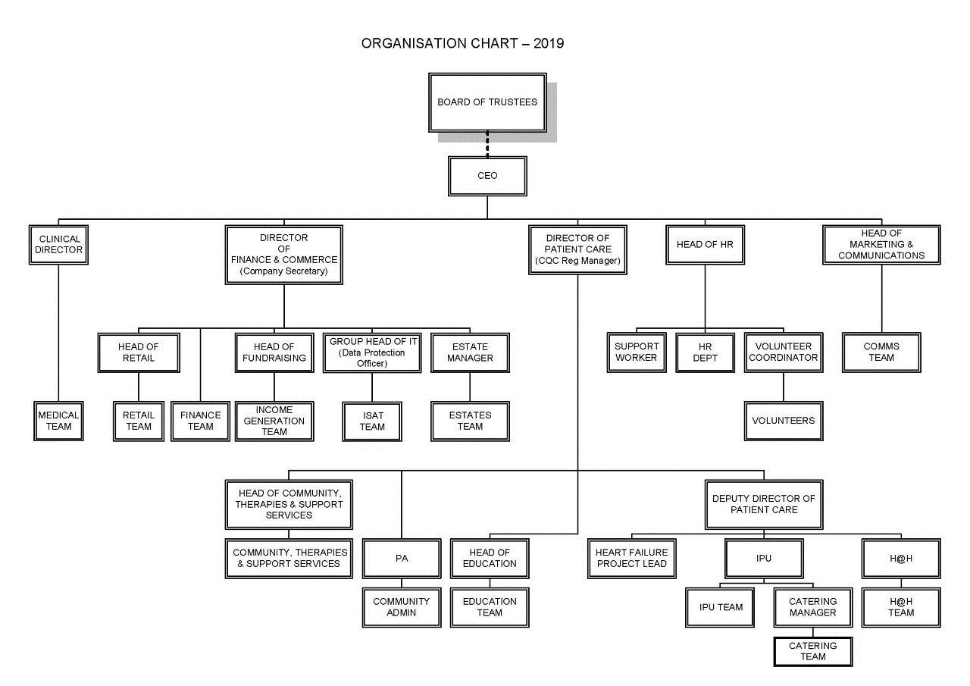
PERSON SPECIFICATION

Attributes | Essential | Desirable
Qualifications, special training and general intelligence | - No formal qualifications.  - Able to demonstrate literacy and numeracy skills.  - Willingness to undertake further training. | - NVQ Level II in Domestic Services.
Knowledge and skills |  | - Knowledge of COSHH and Infection Control principles.
Experience | - None required. | - Previous housekeeping experience in a healthcare environment.
Personal requirements e.g. communication, interpersonal | - Good communication skills.  - Ability to work in a team.  - A positive attitude and commitment to high standards of housekeeping whilst respecting the patient and carers' wishes.  - Ability to use own initiative and prioritise workload.
Other requirements, e.g. Rotas | - Post holder would be expected to work some bank holidays/and or weekends.  - To be flexible in role and hours.

Date: June 2019

